**Name : Mangesh A Ghadwaje**

**Class : SYMCA RollNo : 24**

Data Types, Variables, Constants, and Literals in Java

**Data Types in Java**

**Primitive Data Types**

1. **byte**:
   * Size: 8 bits
   * Range: -128 to 127
   * Used for: Small integers
2. **short**:
   * Size: 16 bits
   * Range: -32,768 to 32,767
   * Used for: Larger integers than byte
3. **int**:
   * Size: 32 bits
   * Range: -2^31 to 2^31 - 1
   * Used for: Most commonly used integer type
4. **long**:
   * Size: 64 bits
   * Range: -2^63 to 2^63 - 1
   * Used for: Larger integer values that exceed the range of int
5. **float**:
   * Size: 32 bits
   * Precision: Approximately 6-7 decimal digits
   * Used for: Decimal numbers where precision is not critical
6. **double**:
   * Size: 64 bits
   * Precision: Approximately 15 decimal digits
   * Used for: Decimal numbers where higher precision is required
7. **char**:
   * Size: 16 bits
   * Represents: Single 16-bit Unicode character
   * Used for: Storing characters and symbols
8. **boolean**:
   * Size: Not precisely defined (typically implementation-dependent)
   * Values: true or false
   * Used for: Boolean expressions and conditions

**Non-primitive Data Types**

* **Classes**: Blueprint for creating objects. They define data and methods.
* **Interfaces**: Similar to classes but only contain method signatures and constants.
* **Arrays**: Objects that store multiple values of the same type sequentially.

### Variables in Java

Variables are named containers that store data values. They must be declared with a specific data type before use. Example declarations:

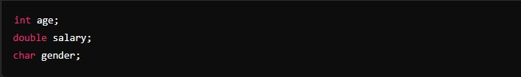

Variables can also be initialized (assigned an initial value) during declaration:

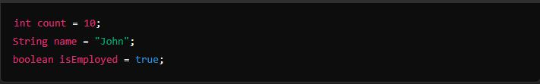

### Literals in Java

Literals are fixed values in Java code that represent themselves. Examples include:

* Integer literals: 10, 0xFF (hexadecimal)
* Floating-point literals: 3.14, 2.0e3 (scientific notation)
* Character literals: 'A', '%'
* String literals: "Hello", "Java"
* Boolean literals: true, false

### Constants in Java

Constants are variables whose values cannot be changed once initialized. They are declared using the final keyword:

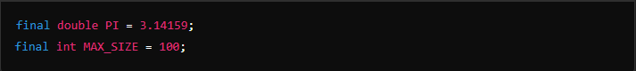

Constants are typically used for values that should remain unchanged throughout the program execution.